**Admin Console Test Cases Results**

**Entity Management**

Row no: 16

|  |  |  |  |  |  |
| --- | --- | --- | --- | --- | --- |
| **Description** | **Test Steps** | **Expected Output** | **Status** | **Test Status** | **Comments** |
| Verify entity creation confirmation email | 1. Create a new entity with valid details. 2. Check the email inbox of the provided email address. | A confirmation email with login credentials should be received. | Pass | Fail | Entity is created and displayed in dashboard, but  Confirmation email is not received. |

Screenshot

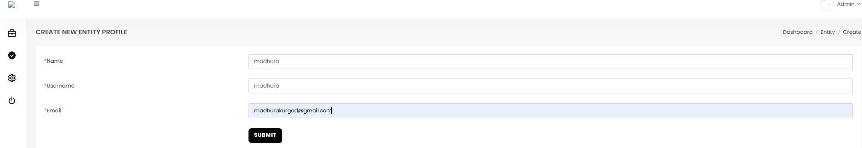

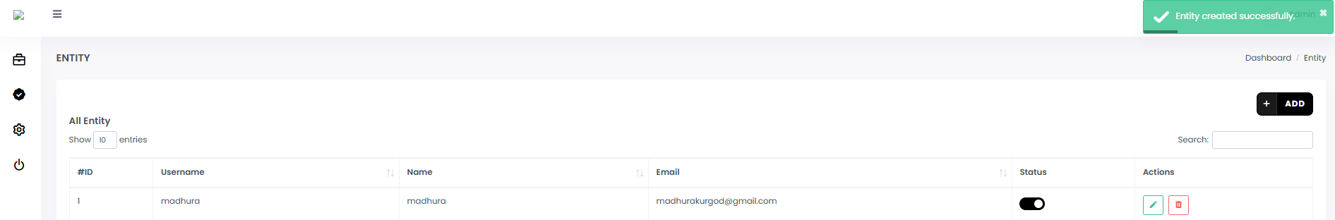

Row no: 17

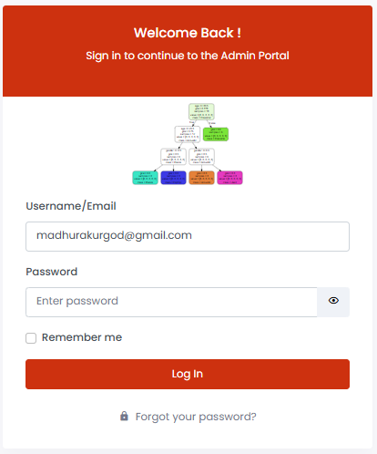

Since confirmation email with email and password is not received on the email address provided during entity creation, user is not able to log in.

|  |  |  |  |  |  |
| --- | --- | --- | --- | --- | --- |
| **Description** | **Test Steps** | **Expected Output** | **Status** | **Test Status** | **Comments** |
| Verify entity login with valid credentials | 1. Use the email and password from the confirmation email. 2. Navigate to the entity login page. 3. Enter the credentials and click "Login". | User should be successfully logged in to the entity portal. | Pass | Fail | Since confirmation email is not received after entity creation, user's successful login to the entity portal cannot be checked. |

**General Setting**

Row no: 6

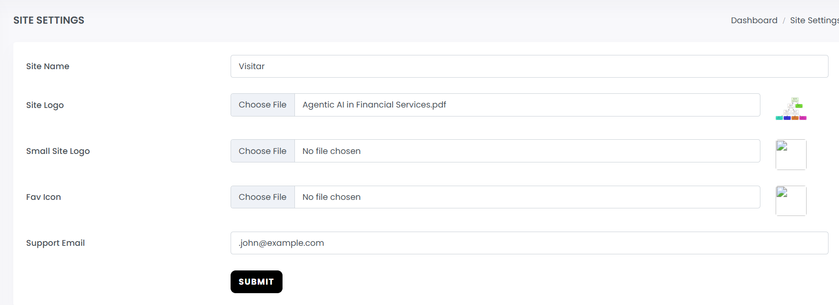

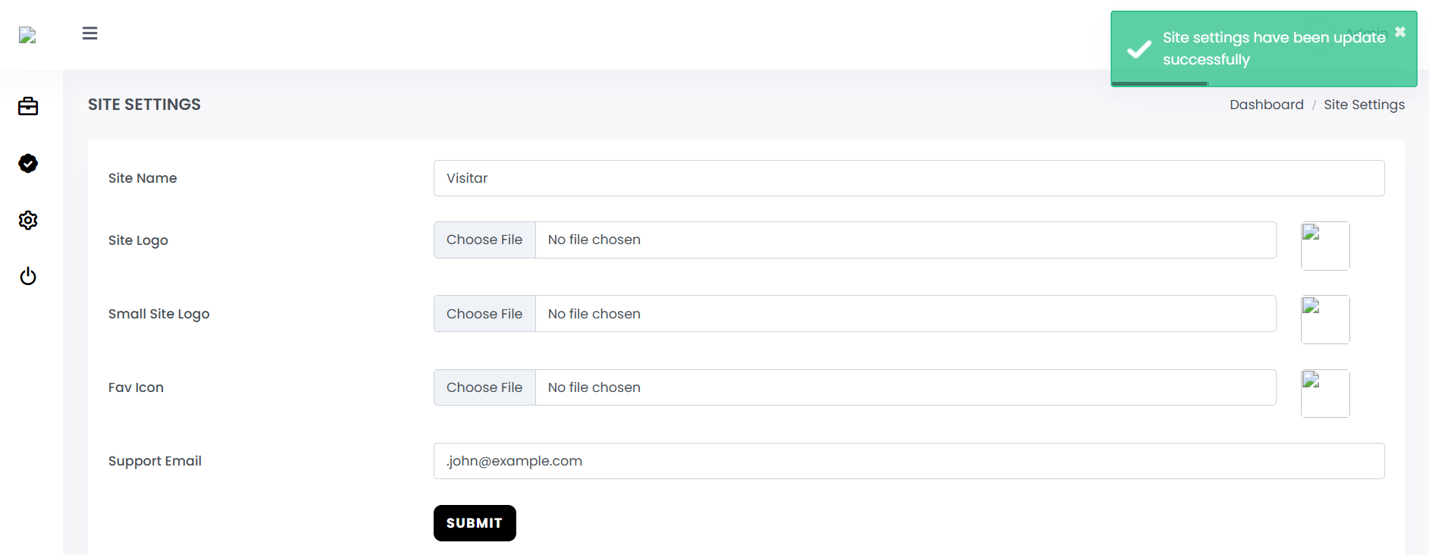

.pdf file was uploaded for Site Logo and an invalid email address was entered for Support Email. Site settings were updated with these changes.

|  |  |  |  |  |  |
| --- | --- | --- | --- | --- | --- |
| **Description** | **Test Steps** | **Expected Output** | **Status** | **Test Status** | **Comments** |
| Verify prevention of invalid file type in image fields | 1. Navigate to the site settings page. 2. Attempt to upload a video or audio file in an image field. 3. Click the 'Submit' button. | The application should prevent the upload and display an error message indicating invalid file type. | **Pass** | **Fail** | Any file type (.docx, .pdf, .txt, .csv, .gz, .rar) is being accepted and the message 'Site settings have been updated successfully' is being displayed on clicking the 'Submit' button |

Row no: 7

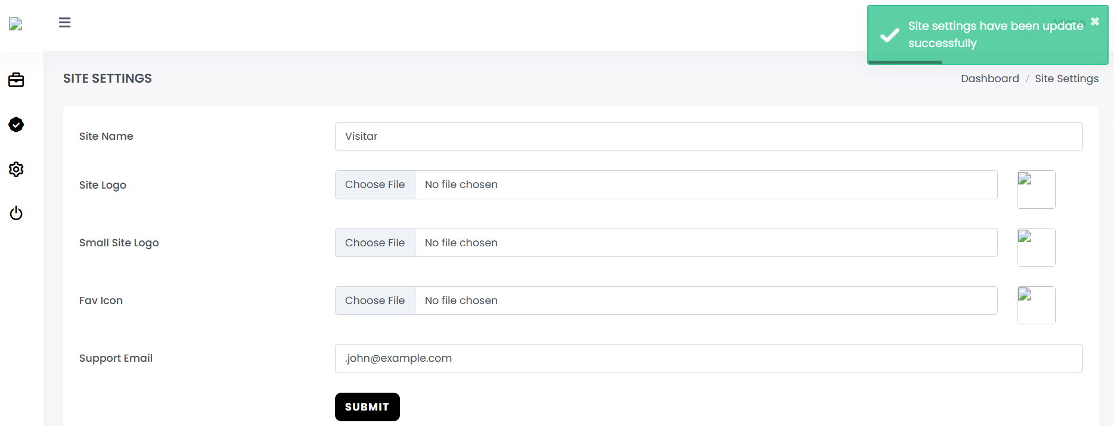

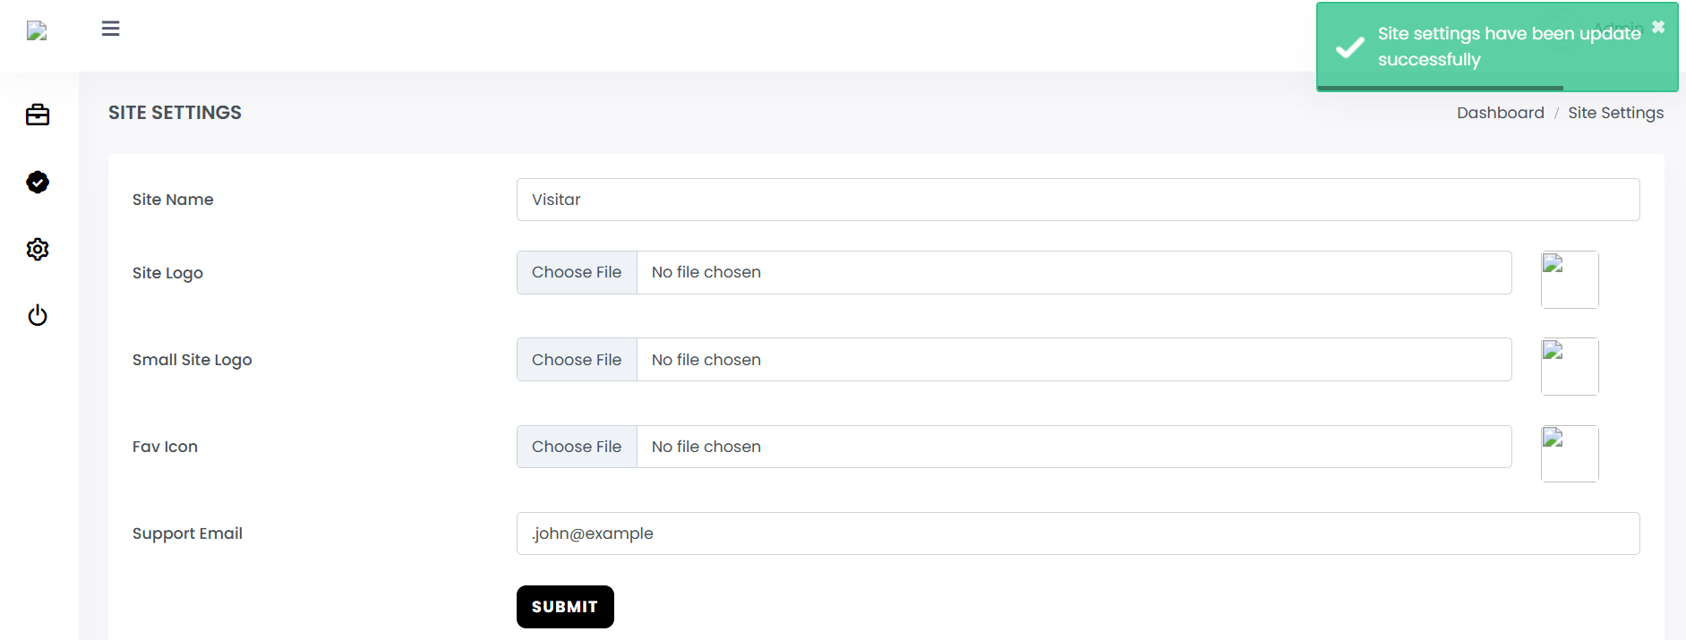

|  |  |  |  |  |  |
| --- | --- | --- | --- | --- | --- |
| **Description** | **Test Steps** | **Expected Output** | **Status** | **Test Status** | **Comments** |
| Verify validation for invalid email format | 1. Navigate to the site settings page. 2. Enter an invalid email address in the email field. 3. Click the 'Submit' button. | A validation message should appear indicating the invalid email format, and the settings should not be updated. | **Pass** | **Fail** | These are the different examples used for testing.  (User@gmail, .john@example.com)-> Accepted   (User.gmail.com, @gmail.com, gmail.com, user@, user yahoo.com,  .john@yahoo.com, john@-domain.com, john@.com  john..doe@example.com, john@.com, john@domain-.com, john@  john@domain..co.uk, user) -> Please enter a valid email address |

**Logout**

Row no: 3

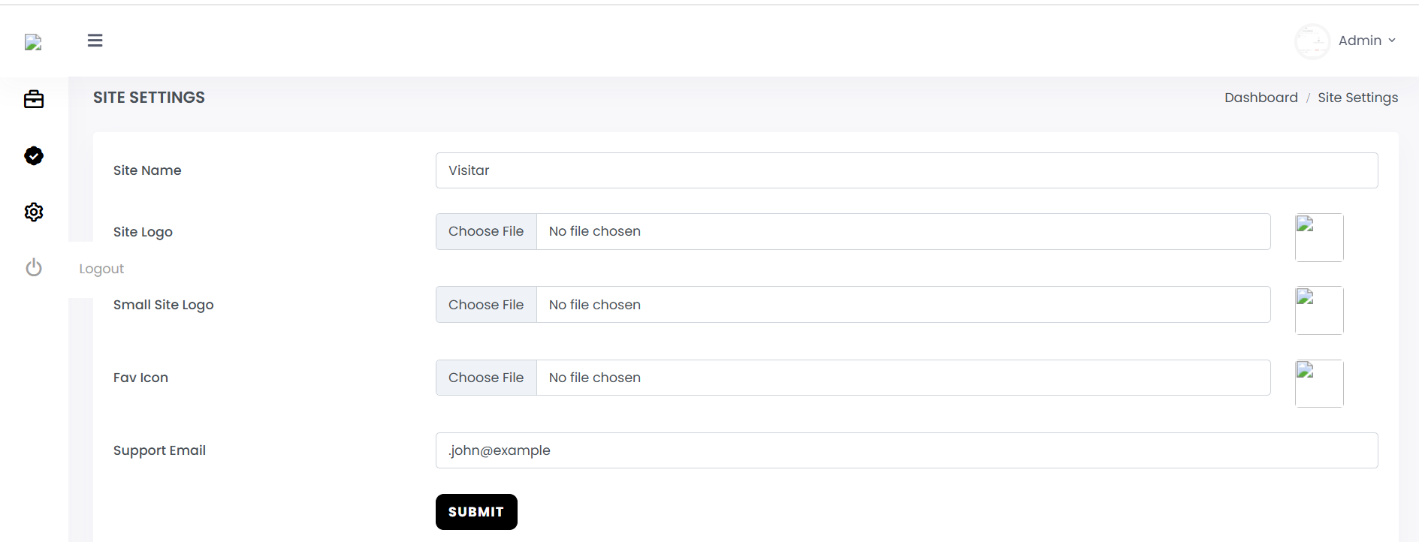

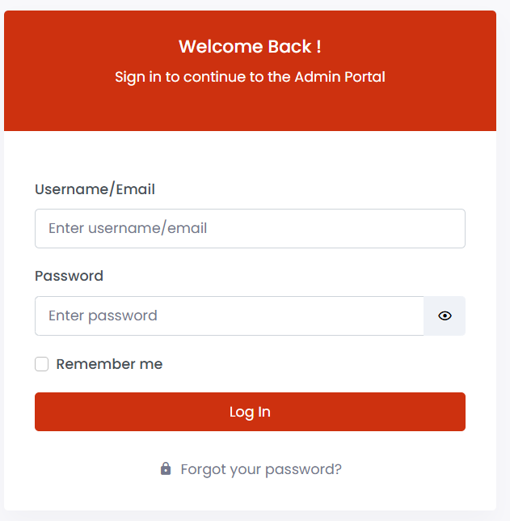

After clicking on back button:

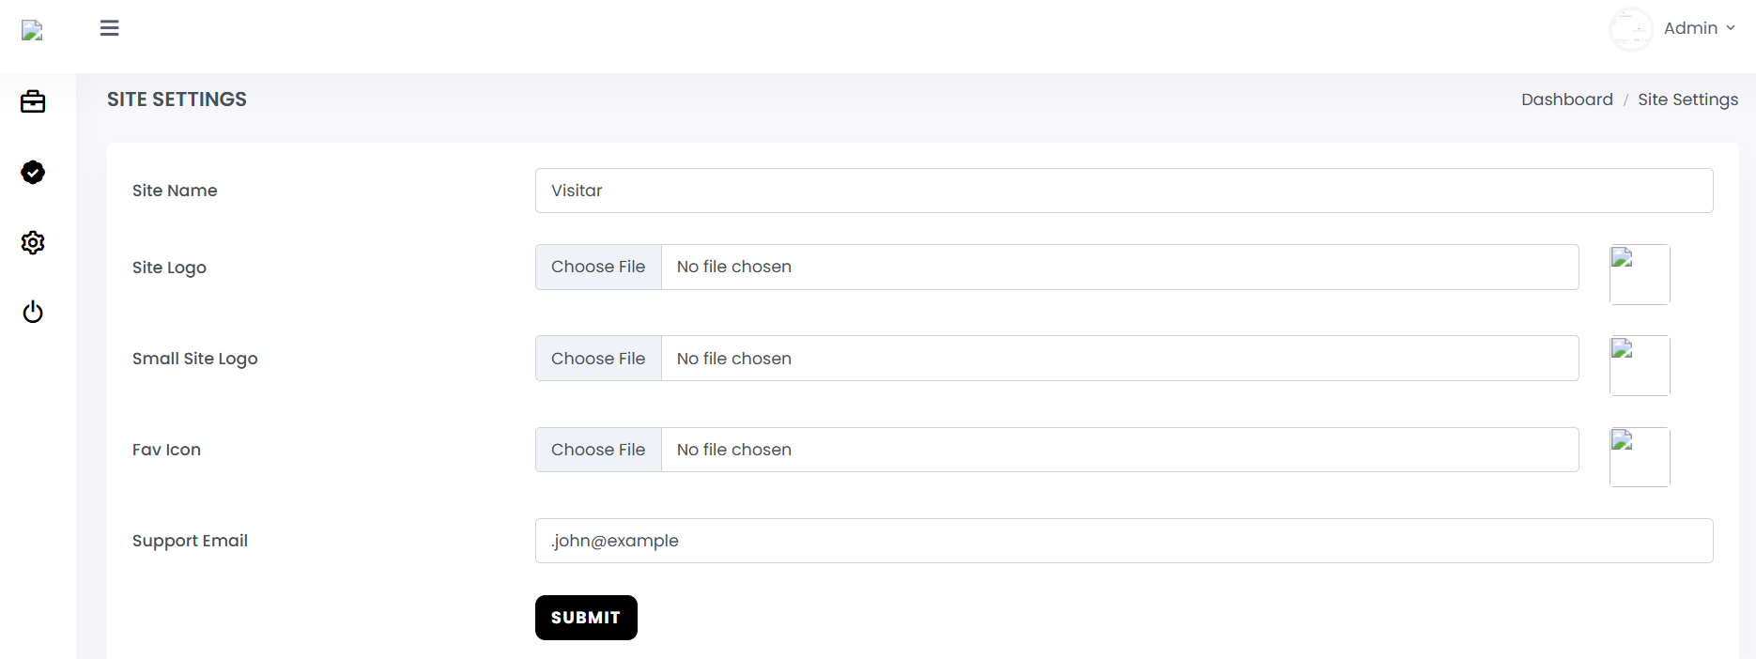

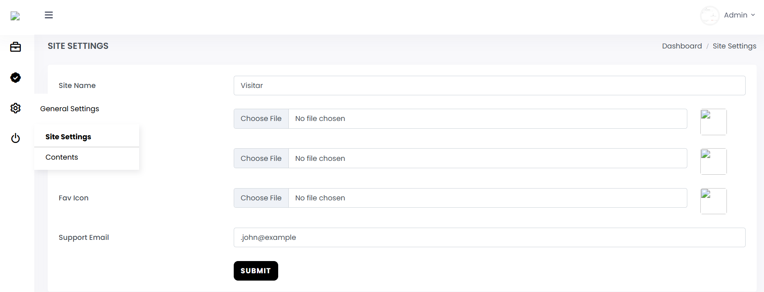

After clicking on Site Settings:



|  |  |  |  |  |  |
| --- | --- | --- | --- | --- | --- |
| **Description** | **Test Steps** | **Expected Output** | **Status** | **Test Status** | **Comments** |
| 1. Click on the back button 2. Click on any of the option | User is logged out from the admin panel and redirected to the login page. | **Pass** | **Fail** | 1. Click on the back button 2. Click on any of the option | When 'Logout' button is clicked, user is redirected to login page. And, when the back button is clicked and changes are made, for example, to the Site Name and 'Submit' button is clicked, the following alert message is displayed:  DataTables warning: table id=users-table - Invalid JSON response. For more information about this error, please see http://datatables.net/tn/1  Subsequent operations are not performed and user is redirected to login page. |